APPLICATION FOR SCHOLARSHIP

IBCO Local 297

Mission Statement
We are committed to carrying on the memory of our brother Richard “Jax” Jaquez formerly of IBCO Local 297 who lived and worked as an exemplary leader, member and loyal friend.
We will carry on his memory by assisting others in their pursuit of educational opportunities. We will raise charitable contributions and award scholarships to worthy applicants who are members of IBCO Local 297, their spouses, significant others, children, step-children, grandchildren, nieces and nephews; students in Berkshire County pursuing higher education and those who are declared criminal justice majors.
We believe this will help our brothers, sisters and their families, and young adults in our communities in the pursuit of their educational and career goals in public service which in turn gives back to our communities.
To achieve our mission, we will:
- Lead one large scale annual event or fundraising drive.
- Plan additional smaller scale fundraising drives
- Determine the number of scholarships awarded and an application process
- Create a fair and just process for the awarding of scholarships

Eligibility Criteria
Applicants must check the box on which scholarship they are applying for. We offer 3 different scholarships:
- Scholarship #1 - The Applicant must be a member of IBCO Local 297, or the spouse, significant other, child, step-child, grandchild, niece or nephew of a member of the Local, seeking funds for assistance in the pursuit of higher education at a two (2) or four (4) year college, graduate school, trade or technical school.
- Scholarship #2 - The Applicant must be a student in Berkshire County seeking said funds for assistance in the pursuit of higher education at a two (2) or four (4) year college, graduate school, trade or technical school.
- Scholarship #3 - The Applicant must be a student in Berkshire County seeking said funds for assistance in the pursuit of higher education at a two (2) or four (4) year college or graduate school with a declared major of criminal justice.

** Applications must be postmarked on or before May 14th, 2022 to be considered. **

Selection Process
Winners will be selected in a lottery drawing in the June 2022 Executive Board Meeting. Three names will be drawn (1 name from each criteria) from the pool of applications submitted. Scholarship winners will be announced on our website http://www.NAGE.org along with our Facebook Page.
In administering the scholarships, neither the Fund nor any of its members shall discriminate against any applicant by reason of race, ethnicity, creed, color, religion, gender, marital status, sexual orientation, national origin, ancestry, age or disability. Each winner (student) can only receive one scholarship per year.

General Information

Only one application may be submitted per applicant. For additional copies of the application, you can:
- Copy the original application
- Download additional copes from our website http://www.NAGE.org
- Apply online http://www.NAGE.org
- Contact the scholarship applications administrator, Michael Charles mlcharles561@gmail.com
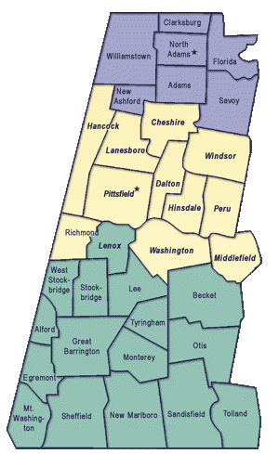
Towns that are considered to be in Berkshire County

Application for Scholarship
** Please print neatly **

Scholarship you are applying for (Please check one box):
Family Member is part of IBCO Local 297
Family Members Name: ______________________
Relationship to Member: _____________________
I am majoring in Criminal Justice and planning on a career in Law Enforcement

General Scholarship

Name: _____________________________________________
Address: _______________________________________ __ City: _______________
State: _______________ Zip: ___________
Phone: _______________________ Home E-Mail : _______________________________
High School Graduating From: _____________________________
College/School Enrolled in: ___________________________________________

Please Mail to:
The “Jax” Fund IBCO Local 297
PO BOX 4134
Pittsfield, Ma 01202

